Greetings again from the Building Committee!

Since our last update in July, we have continued to work behind the scenes with the design and contracting teams.

Major milestones and status:

- Special Permit Amendment (SPA). Approved at Sept. 28th public hearing of the Zoning Appeals Board / allows sale of a portion of our land to County for the neighboring fire station ($90,000)
- Minor Site Plan in process of final submission, after approval of SPA noted above
- Bonding – in process with Fairfax County, Diocesan Missionary Society, and St Peters in the Woods
While there have been many bumps in the road along the way, we have been greatly assisted by the architect and attorneys. We do not know the exact date of the overall permit approvals, but we are optimistic that it will occur in late October or early November. Contractually, the work will begin within 30 days of approval of the Building Permit, the Minor Site Plan, and the Owner posted Bonds. While the Building Permit has been approved, the last two approvals needed are noted in the bullets above. In the meantime, the committee has worked with the architect to select more finishes for surfaces (floors, walls, ceilings, etc.). We have also approved the first payment to the general contractor for materials purchased to preempt cost increases.
The contractor has indicated that from the start of the work we should be able to worship in our current space for about 2 months before we need to worship elsewhere. Fortunately, arrangements have been made by the Vestry for us to worship just across the street at Fairview Elementary School.
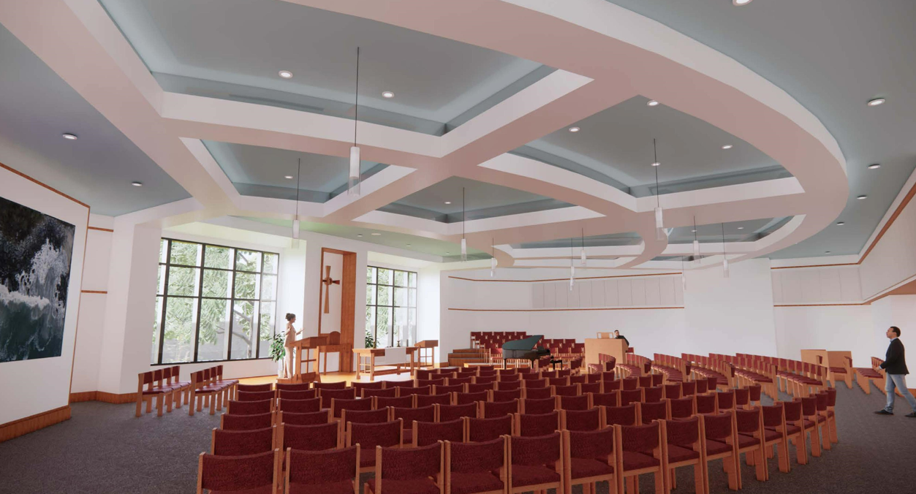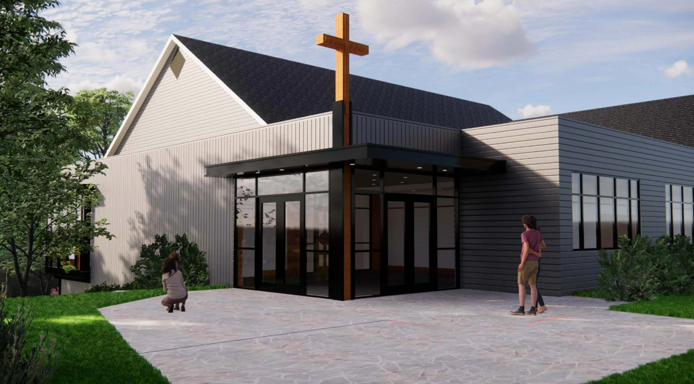
We continue to be excited about the prospect of worshiping in our new space with its bright look reinvigorating us to spread the Word and reach out to others to join us.

